**5. Final Report:**

* **Executive Summary:**
  + Summary of the project: This project aimed to analyse customer data from a retail store to segment customers based on their purchasing behaviour. By identifying these segments, the retail store can make customers satisfaction and boost their sales. Using mall customers dataset, we performed data cleaning, exploratory data analysis, K-means clustering and visualizations using matplotlib and power BI.
  + Objectives: The primary objective of this project is to analyse customer data from a retail store and segment customers into distinct groups based on their purchasing behaviour. By identifying these segments, the retail store can tailor its marketing strategies to better meet the needs of each customer group, ultimately enhancing customer satisfaction and boosting sales.
  + Outcomes: Customer segmentation is a crucial aspect of customer relationship management (CRM) and marketing strategies. In the context of a retail store, understanding different customer segments allows the store to:
* **Develop Targeted Marketing Campaigns:** Tailor promotions and advertisements to specific customer groups based on their purchasing habits and preferences.
* **Personalize Customer Experiences:** Offer personalized recommendations and services to improve customer satisfaction and loyalty.
* **Optimize Product Offerings:** Adjust inventory and product offerings to align with the preferences of different customer segments.
* **Increase Customer Retention:** Implement strategies to retain high-value customers and reduce churn rates.
* **Enhance Sales and Revenue:** Identify opportunities for cross-selling and up-selling to maximize sales and revenue.

By leveraging customer segmentation, the retail store can implement more effective marketing strategies, improve operational efficiency, and ultimately achieve a competitive advantage in the market.

* **Introduction:**

The primary objective of this project is to analyse customer data from a retail store and segment customers into distinct groups based on their purchasing behaviour. By identifying these segments, the retail store can tailor its marketing strategies to better meet the needs of each customer group, ultimately enhancing customer satisfaction and boosting sales.

**Dataset Description:** The dataset used in this project is the "Mall Customers" dataset, which provides information about customers from a mall. The dataset contains demographic and behavioural attributes of the customers, which can be used to perform segmentation. The dataset includes the following columns:

1. **Customer ID:** Unique identifier for each customer.
2. **Gender:** Gender of the customer (Male/Female).
3. **Age:** Age of the customer.
4. **Annual Income (k$):** Annual income of the customer in thousands of dollars.
5. **Spending Score (1-100):** Spending score assigned by the mall based on customer behaviour and spending nature (1 being lowest and 100 being highest).

**Dataset Snapshot:**

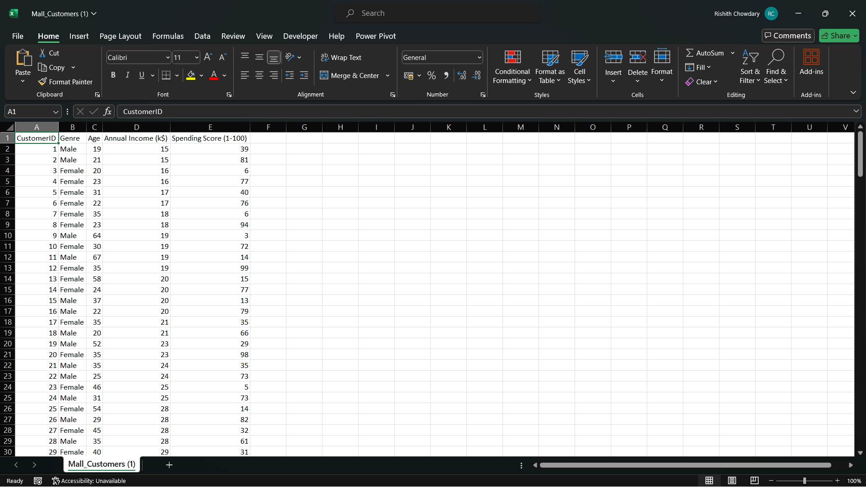

**Attributes:**

* **Customer ID:** A numerical identifier unique to each customer.
* **Gender:** Categorical variable indicating the customer's gender.
* **Age:** Numerical variable indicating the customer's age.
* **Annual Income (k$):** Numerical variable indicating the customer's annual income in thousands of dollars.
* **Spending Score (1-100):** Numerical variable indicating the spending score, a metric assigned by the mall based on customer spending behaviour.

**Purpose of the Dataset:** The dataset is used to perform customer segmentation analysis. By examining the demographic and behavioural attributes of the customers, we aim to identify distinct groups of customers who exhibit similar purchasing behaviours. These insights will enable the retail store to develop targeted marketing strategies and enhance overall customer satisfaction.

**Data Source:** The dataset is publicly available and can be downloaded from Kaggle at the following link: https://www.kaggle.com/datasets/shwetabh123/mall-customers

**Data Analysis and Segmentation:** In this project, we will:

1. **Clean the data** to handle missing values and ensure consistency.
2. **Perform Exploratory Data Analysis (EDA)** to understand the distribution and relationships within the data.
3. **Apply K-Means Clustering** to segment customers into distinct groups.
4. **Visualize the results** using Matplotlib and Power BI to gain actionable insights.

* **Methodology:**
  + **Data Collection:** We used the "Mall Customers" dataset, which contains demographic and behavioural attributes of customers, such as Customer ID, Gender, Age, Annual Income, and Spending Score​
  + **Data Cleaning:** Handled missing values and ensured data consistency.
  + **Exploratory Data Analysis (EDA):** Performed EDA to understand data distribution and relationships within the dataset.
  + **Clustering Analysis:** Applied K-Means Clustering to segment customers into distinct groups.
  + **Visualization:** Used Matplotlib and Power BI to visualize the results and gain actionable insights.
* **Results:**
  + Analysis of age, gender, annual income, and spending score provided insights into customer demographics.
  + K-Means Clustering identified distinct customer segments based on purchasing behaviour.
  + Power BI visualizations highlighted the distribution and characteristics of each customer segment which gives clear view on data.
* **Conclusion:**
  + **Targeted Marketing:** Tailor promotions and advertisements to specific customer groups based on their purchasing habits and preferences.
  + **Personalize Customer Experiences:** Offer personalized recommendations and services to improve customer satisfaction and loyalty.
  + **Optimize Product Offerings:** Adjust inventory and product offerings to align with the preferences of different customer segments.
  + **Increase Customer Retention:** Implement strategies to retain high-value customers and reduce churn rates.
  + **Enhance Sales and Revenue:** Identify opportunities for cross-selling and up-selling to maximize sales and revenue.
* **Appendices:**
  + Additional charts:

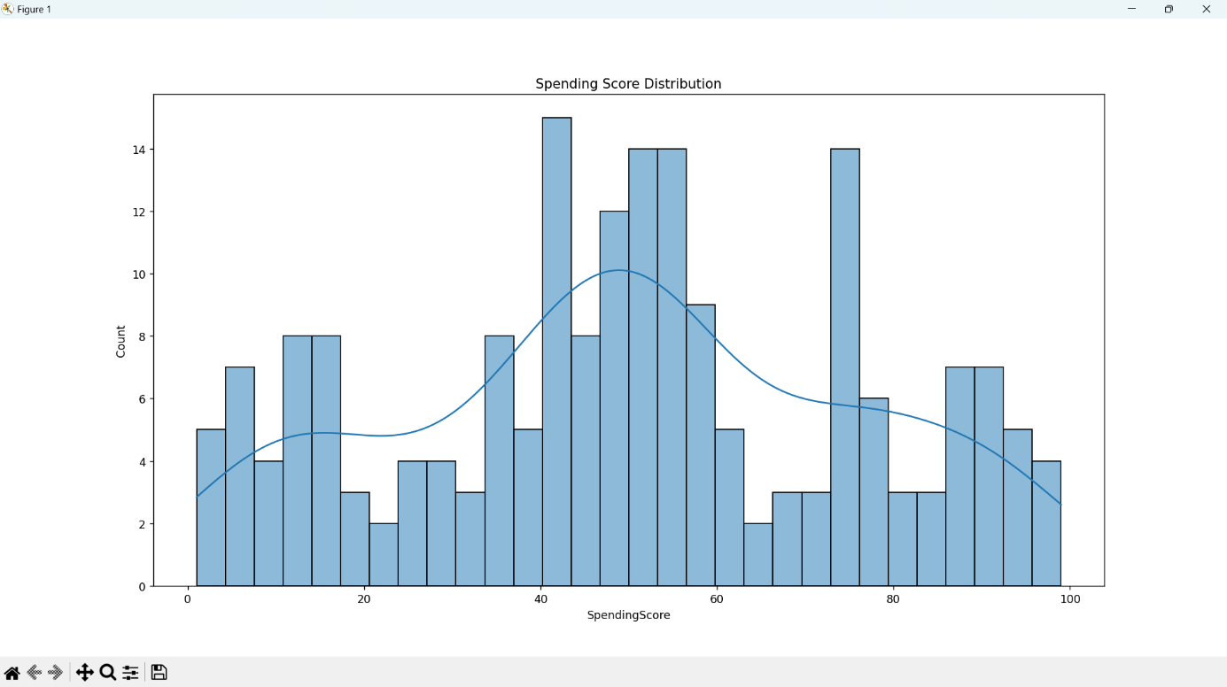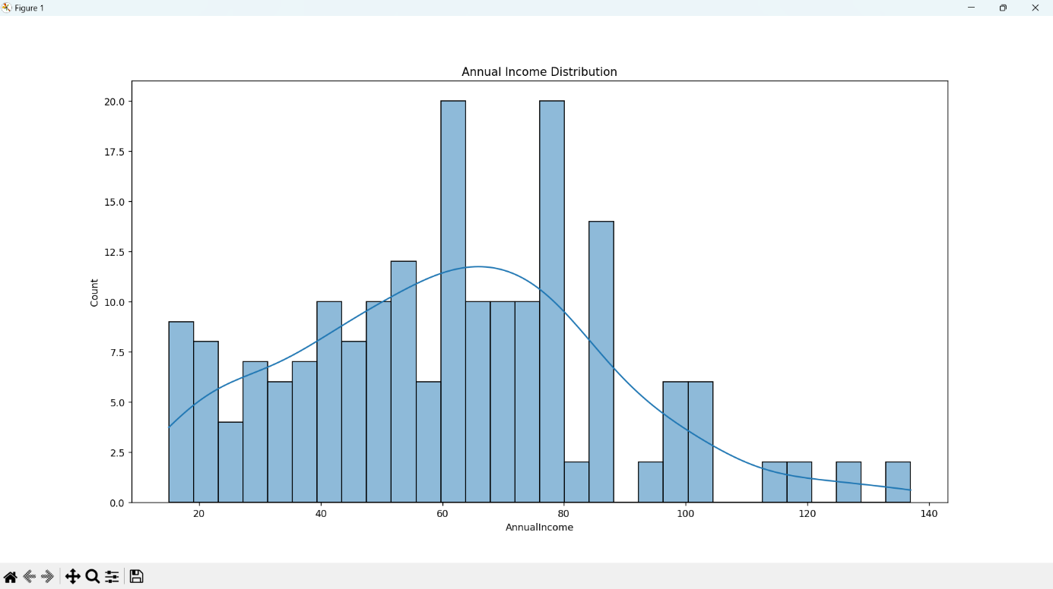Visualization using Matplotlib:

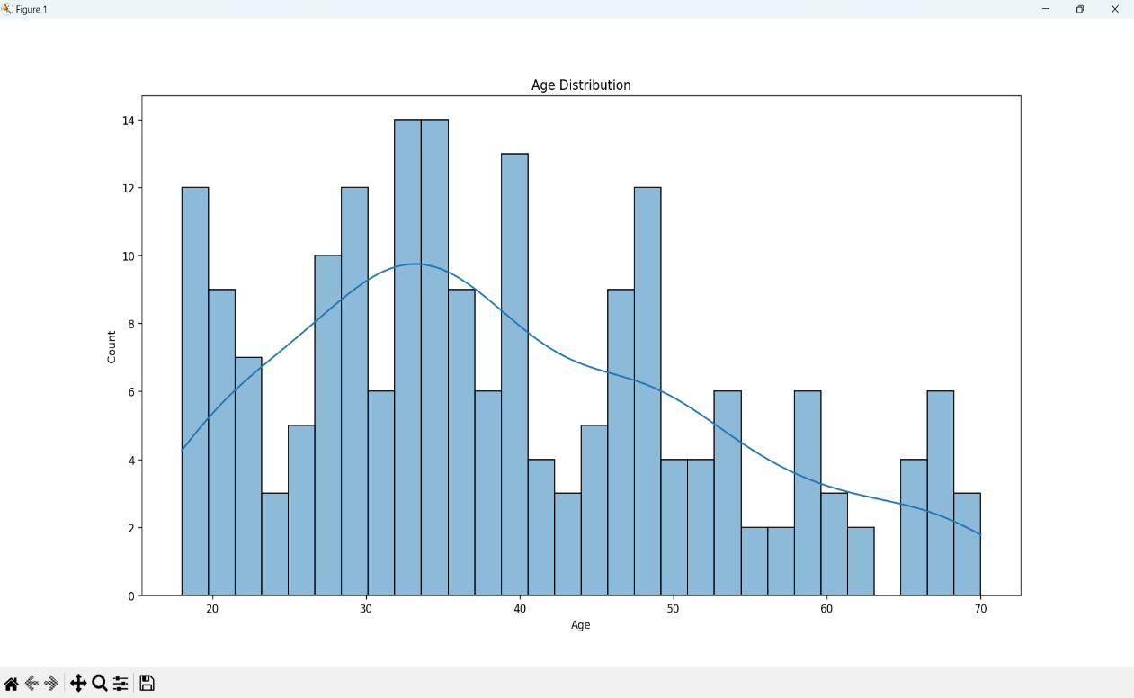

Visualizing Relationships:

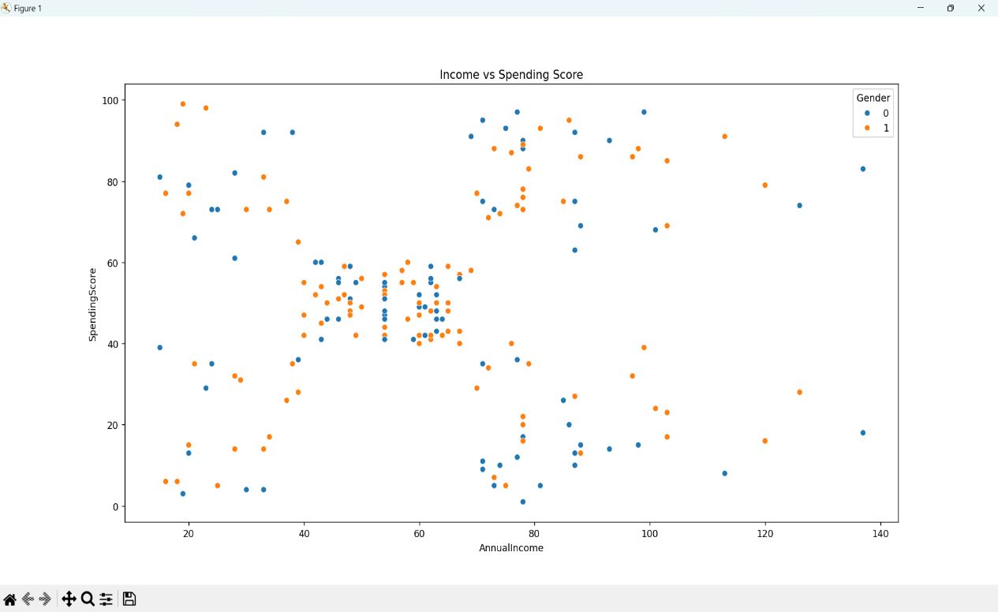

K-Means Clustering:

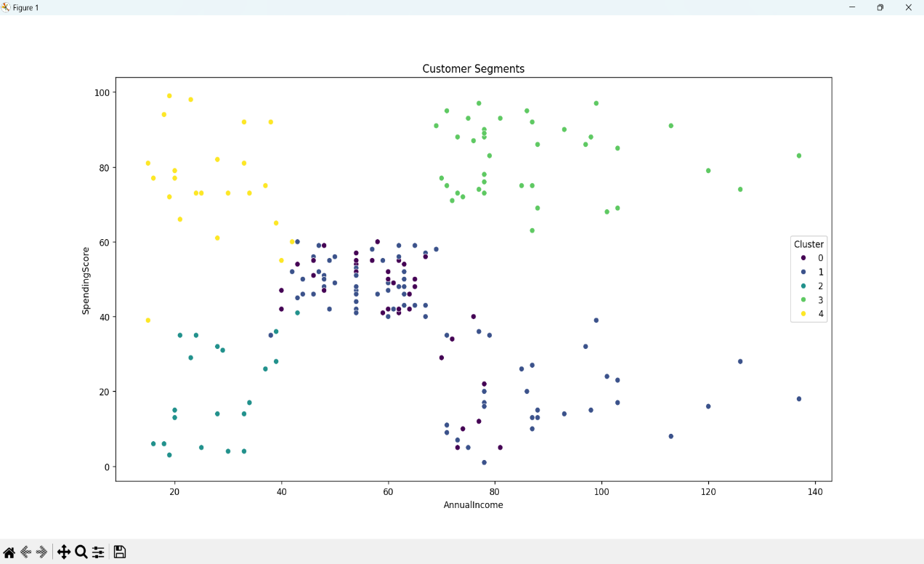

Visualizations using Power BI:

Donut Chart:

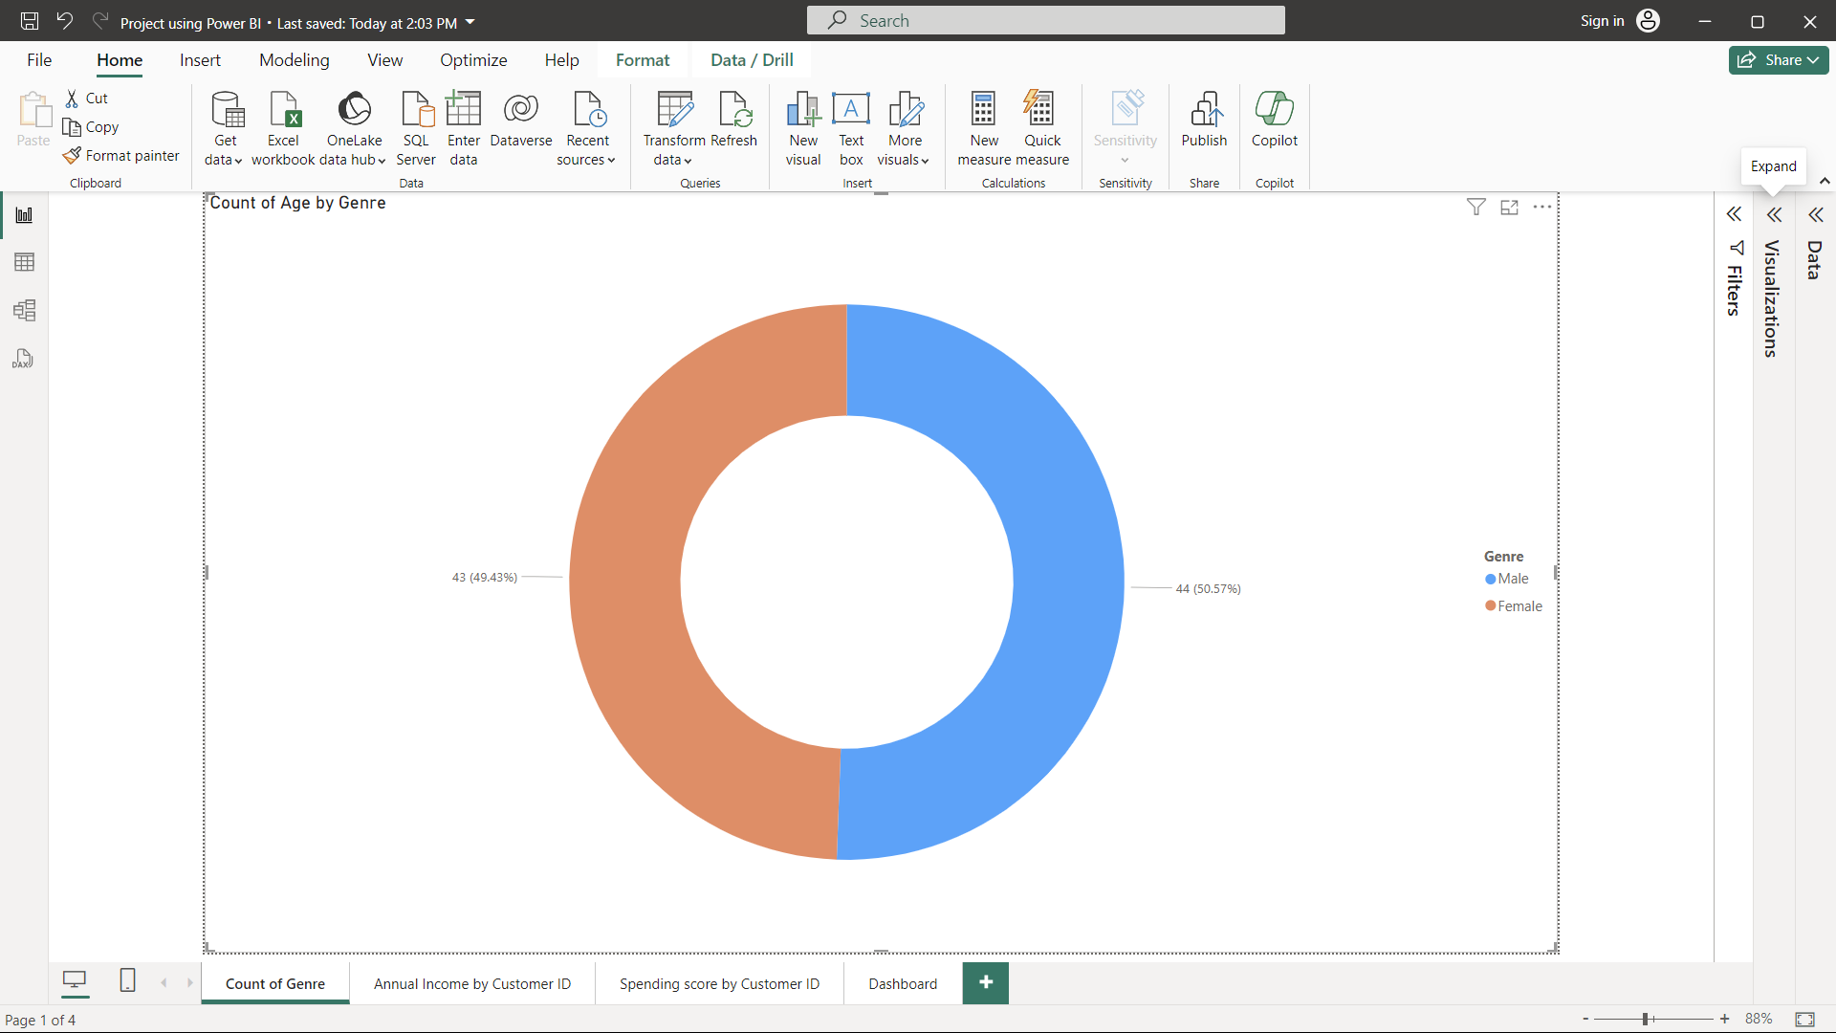

Stacked Column Chart:

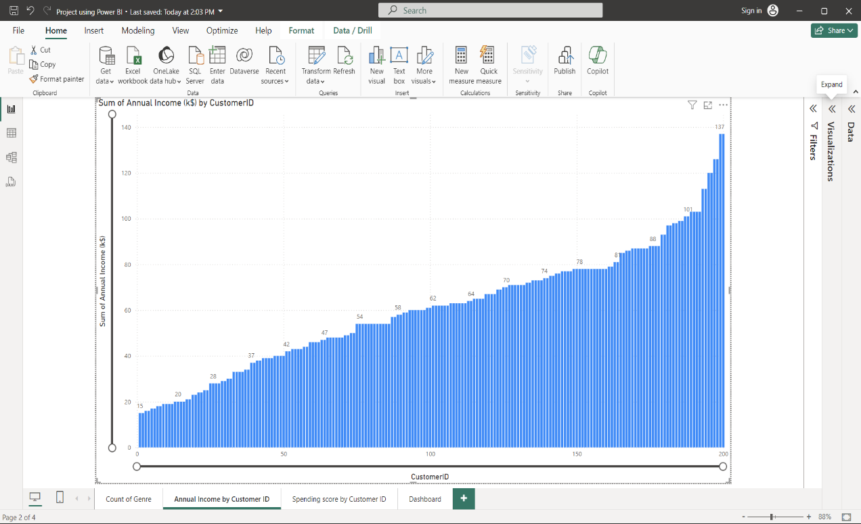

Stacked Area Chart:

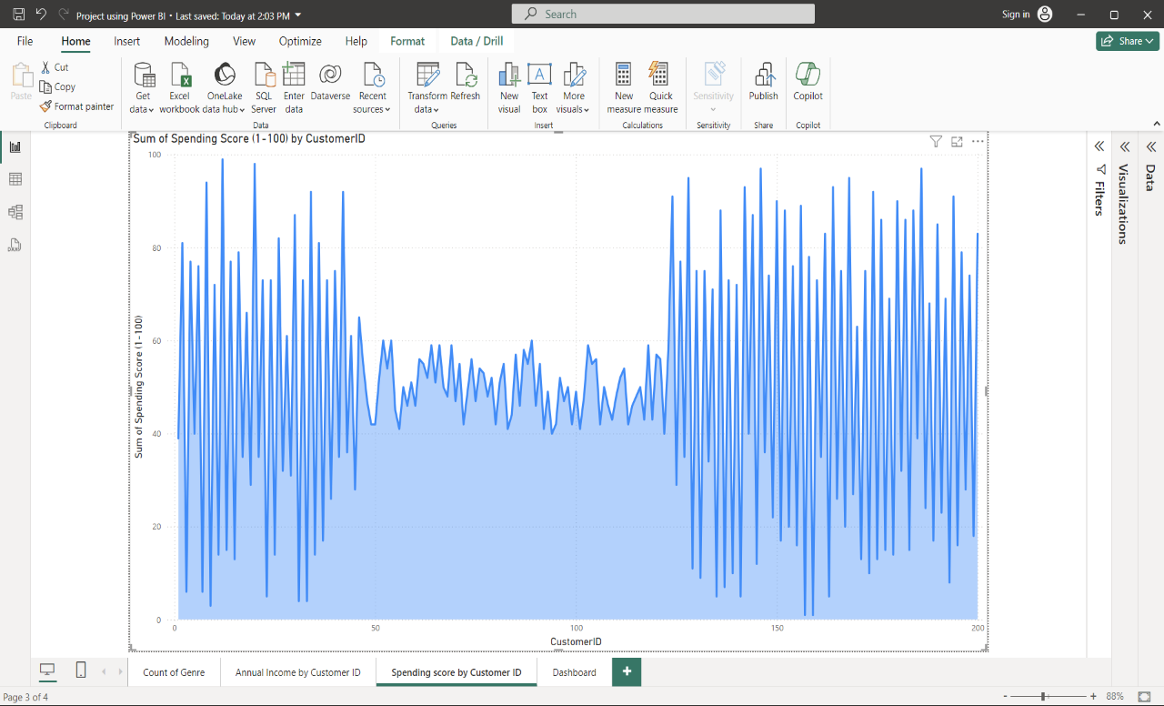

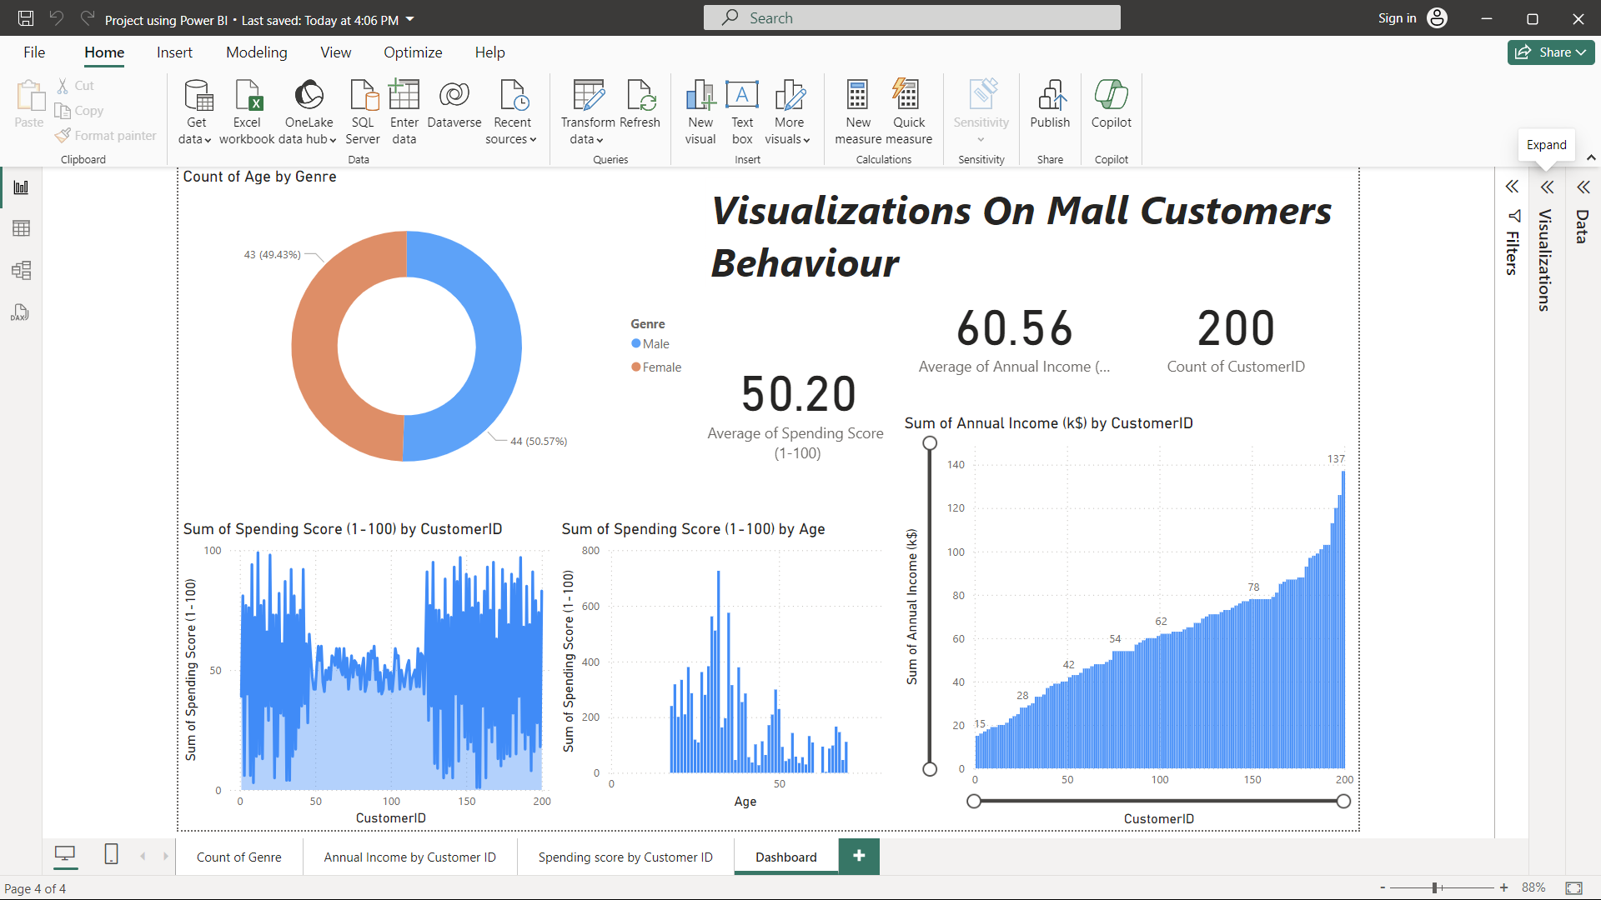Power BI Dashboard:

* + 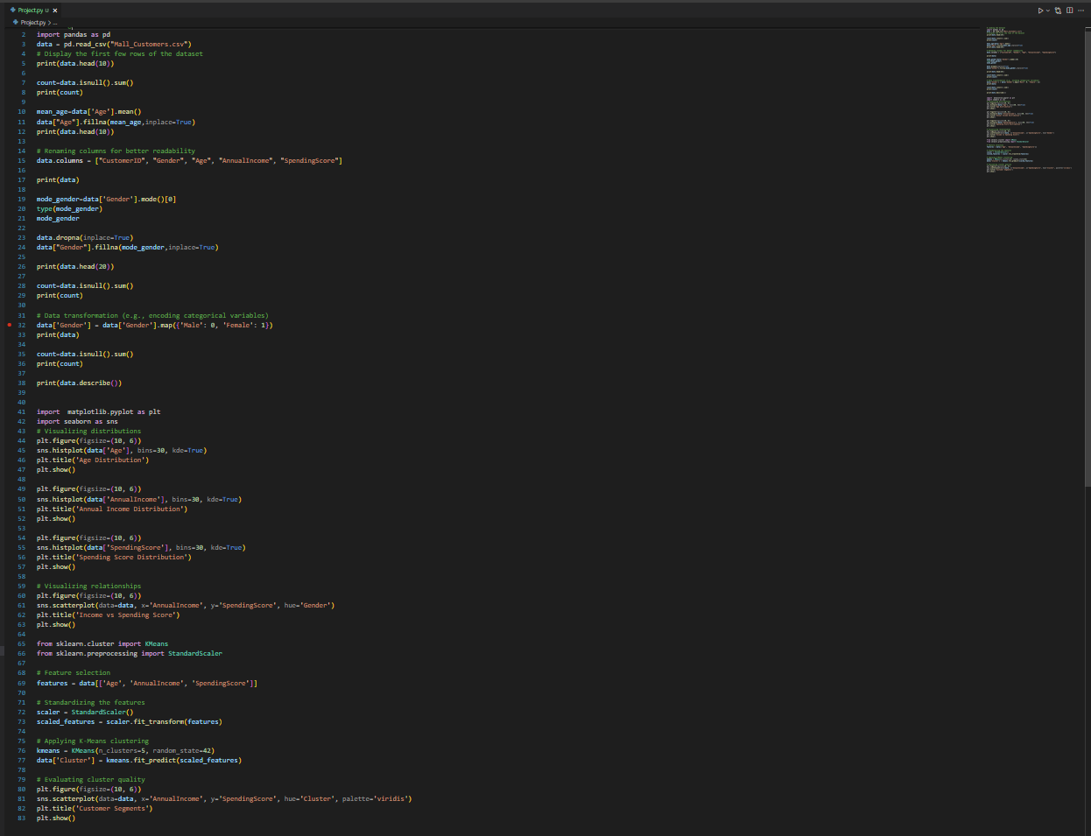 Code Snippets:
  + References:

Dataset: <https://www.kaggle.com/datasets/shwetabh123/mall-customers>